BIT × INFINEON
Water Supply App
Frontend Architecture
Client-side structure, view catalogue, and illustrations of the interface as actually rendered for the water management module.
Scope | Backend status | Version
Frontend layer only | Integration in progress | Revised — screenshots added

Presentation document — frontend layer · August 2026

This document describes only the organization of the client (interface, views, components, design system) and shows the application as it currently renders. As the backend is still under development, the screens shown reflect an environment with no real data (empty states), which makes it possible to validate the interface's behavior in that scenario.

1. PURPOSE OF THE DOCUMENT

Frontend scope and organization
This document presents the frontend architecture of the Water Supply App: how the client application is organized, which views and components make it up, and how it relies on an API layer to retrieve its data. The goal is to give a clear picture of the interface for the project review — from the overall structure down to the business views — illustrated at each point by the application as it currently runs.
The frontend is a single-page web application (SPA) built with React 19 and Vite, styled with Tailwind CSS v4 and a dedicated design system, with Recharts for data visualization and lucide-react for icons. The code is organized into a dedicated “water” domain module, complemented by a shared layer of components and hooks reused throughout the application.

Navigation organization
The application is structured around two functional groups exposed in the side menu: Data management, which covers reference data (farms, fields, zones), and Water saving planning, which groups the operational views (dashboard, irrigation, consumption, rainwater, drip maintenance, quality, and drought). Each view follows the same pattern: data retrieval via a dedicated hook, display using shared components and charts, and explicit handling of three states — loading, error, empty — so the interface never shows a blurred or ambiguous screen.

Current integration status
The backend is currently under development. The screenshots below therefore show the connected application (a “Backend connected” indicator visible on the dashboard) but without business data entered yet: it is this empty state, built in by design, that is illustrated in this document rather than the details of server exchanges.

2. APPLICATION STRUCTURE

The frontend layers
Layer | Content | Notes
Application shell | Side navigation, section grouping, toast notifications | 240px sidebar, 76×60 logo block
Design system | Color tokens and typographic scale (--ws-* variables) | Inter for body text, Montserrat for titles and KPIs
Shared components | Spinner, EmptyState, ConfirmDialog, FormField, DataTable | Reused across all views, no additional dependency
Chart layer | WsAreaChart, WsBarChart, WsRadialGauge | Built on Recharts, styled with the module’s palette
Data access | Domain-specific hooks (dashboard, farms, water data) on top of a shared API client | Backend service detail not covered here — integration in progress

Design system — visual reference
Element | Specification
Primary color | #0a8276 (teal)
Accent colors | Orange #ef6c00 · Red #c62828 · Green #4caf50
Typography | Inter (body text, navigation, tables) · Montserrat (titles, KPIs)
Title / KPI sizes | Section titles 24px/600 · KPI values 32px/700
Sidebar | 240px wide

3. BUSINESS VIEW CATALOGUE

Eight views, one shared pattern
View | Data source | Key interface elements
Dashboard | KPIs, alerts, activity log, AI recommendations, drought forecast, weather | KPI cards, alert list, recommendation panel
Farms & Fields | Farms / fields / zones | Data table with create, edit, delete, confirmation dialog
Irrigation | Irrigation schedules and logs | Schedule list, manual start/stop controls, history
Consumption | Water consumption readings | Area chart, period filter (week/month/all), KPI summary
Rainwater | Rainwater harvests and sources | Radial gauge, bar chart, KPI summary
Drip maintenance | Maintenance log | Chronological list of interventions
Water Quality | Water quality test results | Table with color-coded pH/turbidity indicators
Drought Alerts | Drought risk forecast | Risk gauge, tier indicator, recommendations
The following pages show five of these views as they currently render in the application (localhost:5173), before business data arrives.

4. APPLICATION AS-IS — SCREENSHOTS

Dashboard view
Entry view of the application; it assembles seven data sources in parallel (KPIs, alerts, activity, AI recommendations, drought, weather, backend status).
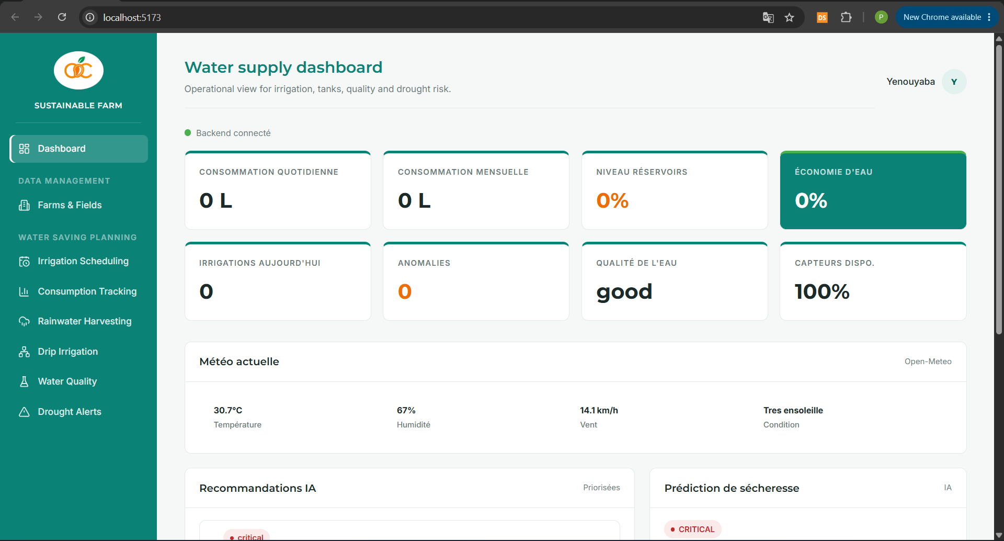
DASHBOARD
Dashboard — operational overview
The green “Backend connected” indicator at the top confirms the API link is responding; the eight KPI cards (consumption, tank level, water savings, today’s irrigations, anomalies, quality, sensors) all show zero or default values because no farm has been created yet. The weather block (Open-Meteo), meanwhile, stays fed in real time independently of business data.
- Each KPI card behaves as an independent block: it shows its own value as soon as its source responds, without blocking the rest of the screen.
- The “Water savings” card uses the solid accent color to highlight it, in line with the design system.
- The “AI Recommendations” and “Drought Forecast” panels are ready to display priority content as soon as the backend supplies data.

4. APPLICATION AS-IS — SCREENSHOTS

Farms & Fields, then Irrigation Scheduling
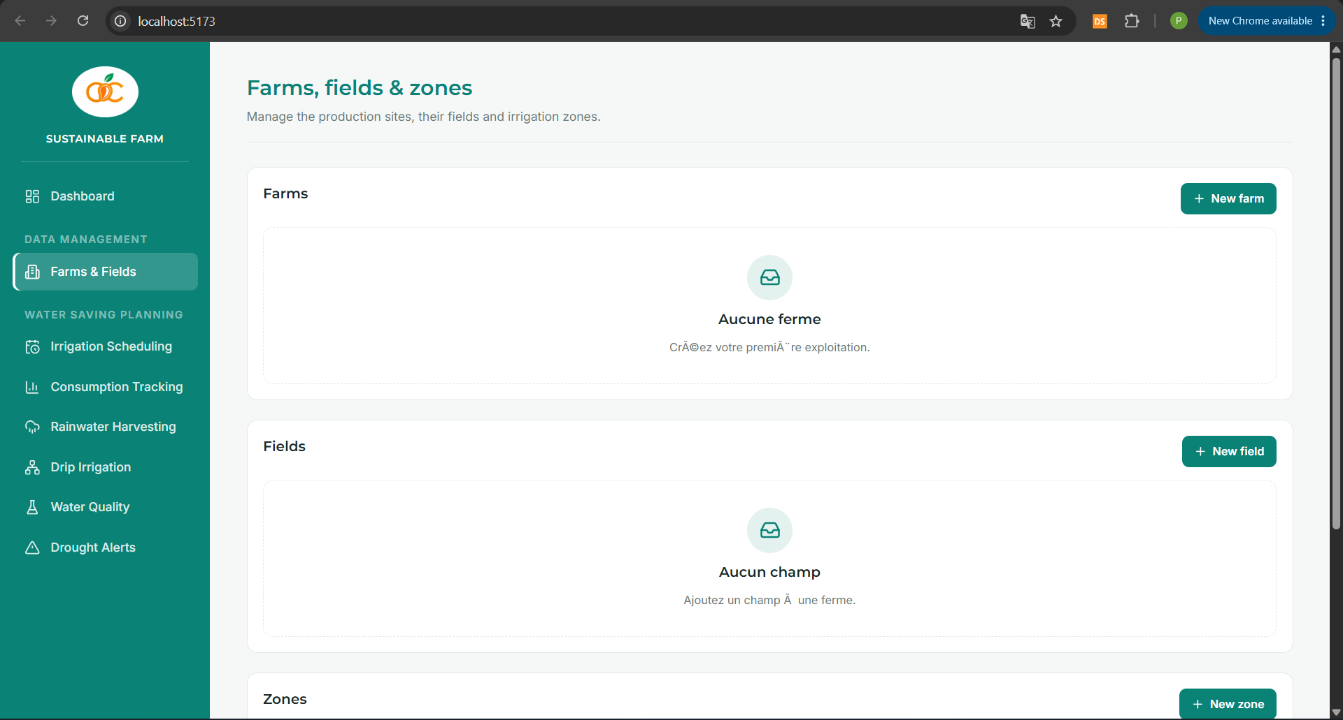
FARMS
Farms & Fields — reference data management
This view groups three stacked tables (Farms, Fields, Zones), each with its own creation button. With no farm created, each table shows its dedicated empty state.
- “No farm” / “No field” illustrate the shared EmptyState component, with icon, message, and helper text, rather than a blank table.
- The “New farm,” “New field,” and “New zone” buttons remain active: creation stays possible even when the list is empty.

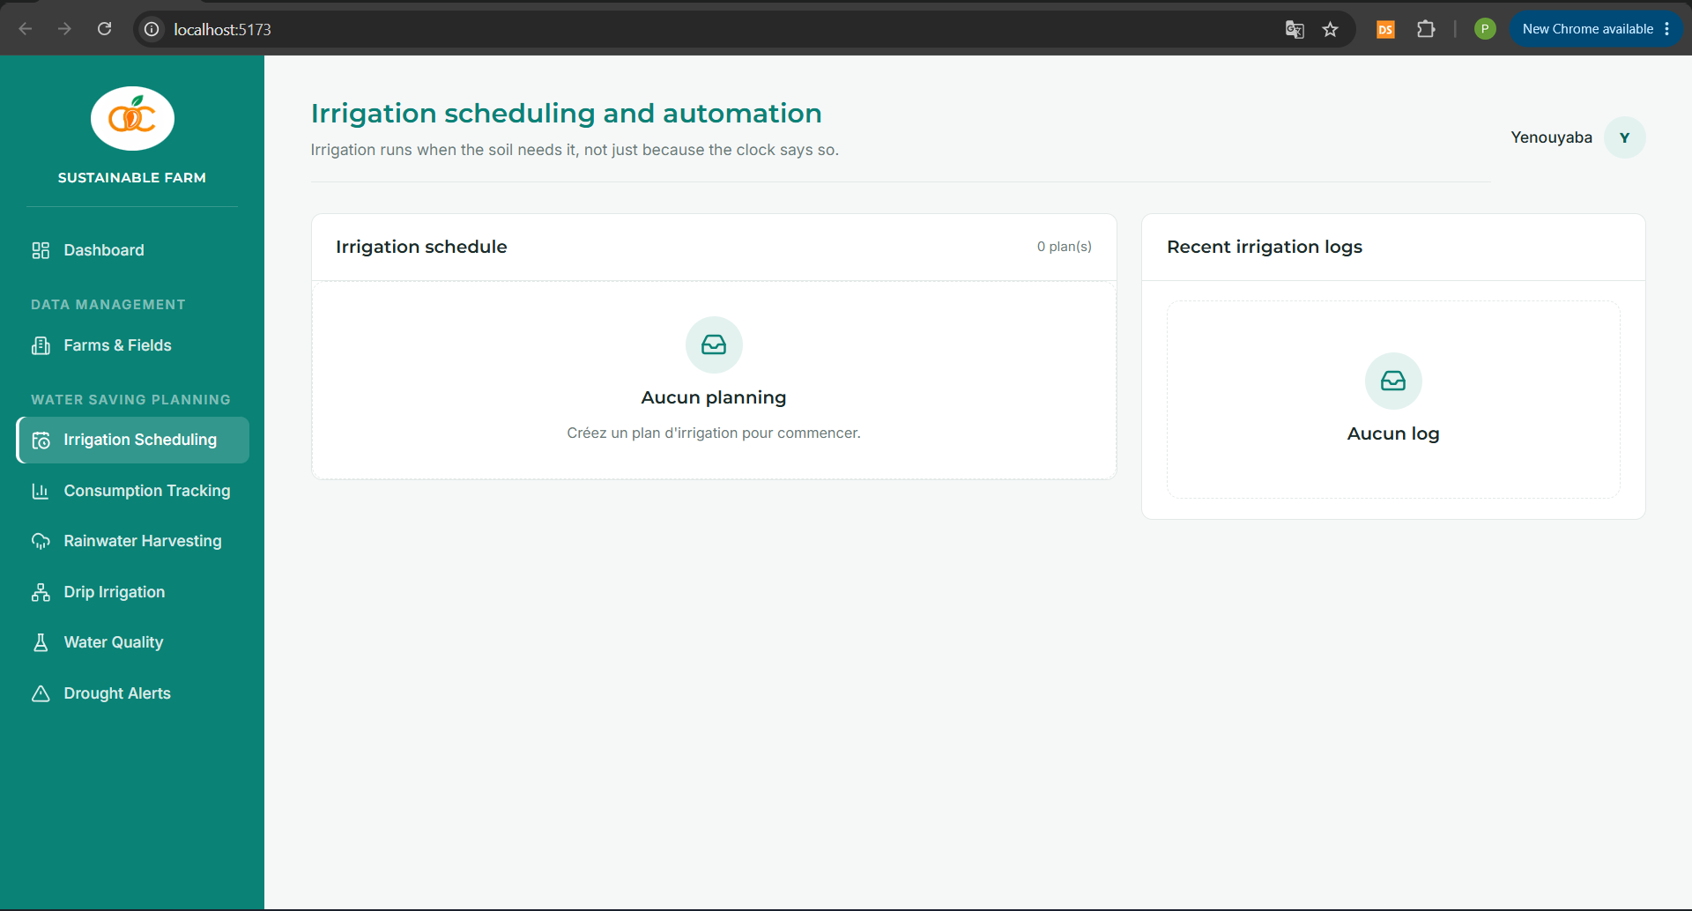
IRRIGATION
Irrigation Scheduling — planning and automation
The view combines an irrigation schedule on the left and the intervention history on the right, both empty until a plan has been created for a zone.
- The message “Create an irrigation plan to get started” guides the user toward the next action rather than simply reporting the absence of data.
- The two panels (schedule and log) are independent, as expected from the shared loading/error/empty pattern applied to each block.

4. APPLICATION AS-IS — SCREENSHOTS

Consumption Tracking, then Rainwater Harvesting
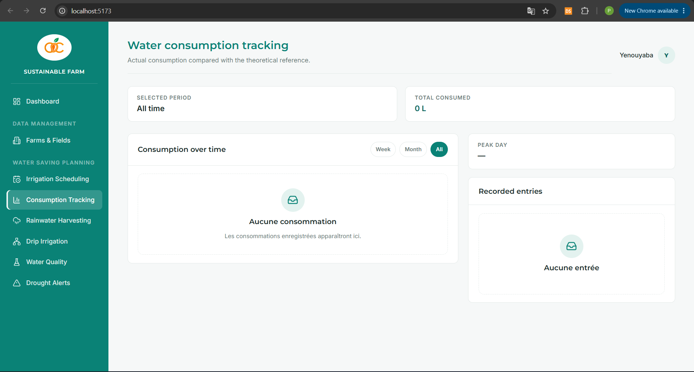
CONSUMPTION
Consumption Tracking — actual consumption monitoring
The view combines a period selector (Week/Month/All), an area chart zone, and a recorded-entries panel; the whole section stays at 0 L in the absence of readings.
- The chart component (WsAreaChart) is already in place and ready to receive time series as soon as readings are recorded.
- The period filter works independently of the content: it stays selectable even when no data is available for the chosen period.

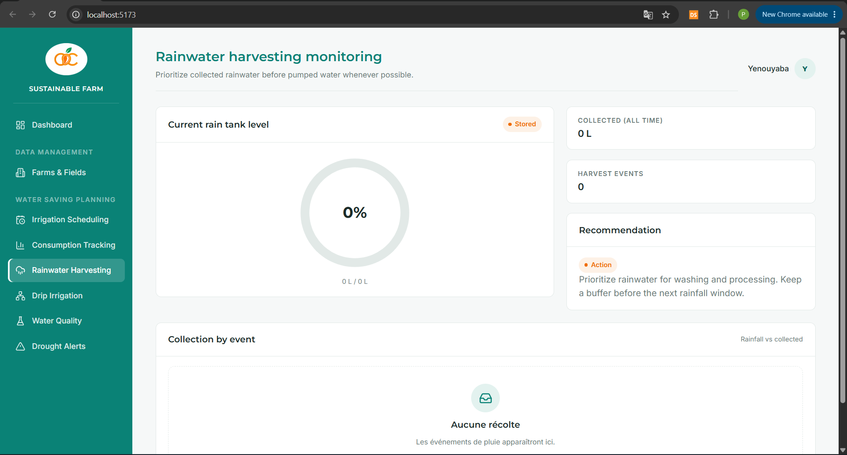
RAINWATER
Rainwater Harvesting — rainwater collection monitoring
This view combines a radial gauge for tank level, “Collected” and “Harvest events” indicators, and an automatically generated recommendation panel.
- The radial gauge (WsRadialGauge) shows 0% with the “0 L / 0 L” label, confirming it correctly handles the case where the tank capacity is not yet defined.
- The “Recommendation” panel stays active despite the absence of data: it already offers generic advice (“Prioritize rainwater…”), which will be refined once real data is available.

5. SUMMARY AND NEXT STEPS

What is in place on the frontend
The application shell, the shared component library, the chart layer, and the eight business views form a coherent frontend structure for the Water Supply module, aligned with the design system. The screenshots shown confirm that each view applies the same pattern: loading, then display of data or, as here, a clear and actionable empty state in the absence of data.
As the backend is still under development, the actual data exchanges (creating farms, recording readings, feeding AI recommendations) have deliberately not been detailed in this document: they will be the subject of a dedicated review once the integration has stabilized.

Step | Description
Backend integration | Finalize the connection of the eight views to the real services and validate loading/error states with live data
Demo data set | Create a first farm to verify the display of tables, charts, and gauges with content
Dedicated backend review | Separate document, once the API has stabilized
This document serves as a reference for reviewing the frontend structure; as the application evolves, new views or screenshots may be added to the same catalogue.

